1. Issue new Deskdop Machine which will be used as database server for thinkPro.
2. Open Lan Port For desktop Machine(CR Required)

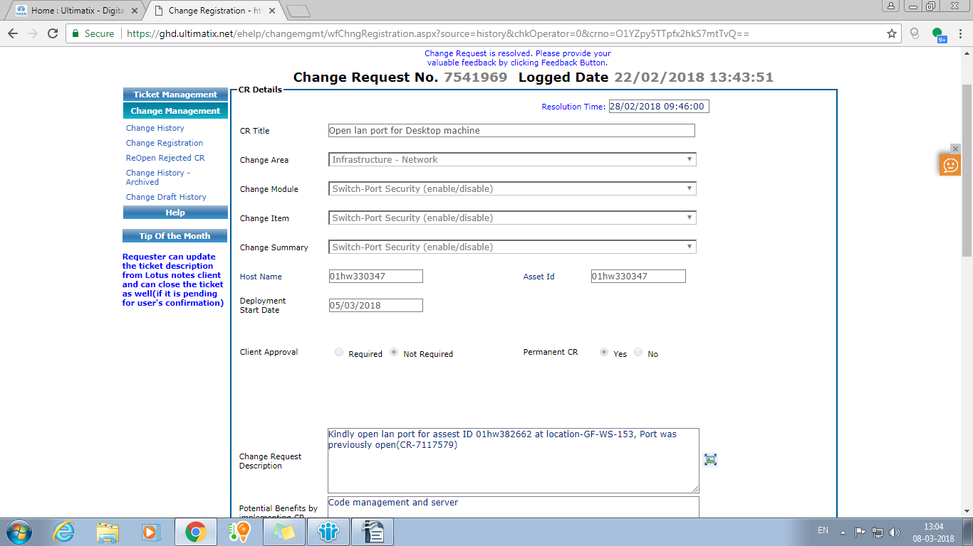

3)Install PostgresSQL in the server system(set the default password of database as [TCS@1234](mailto:TCS@1234) while installing)

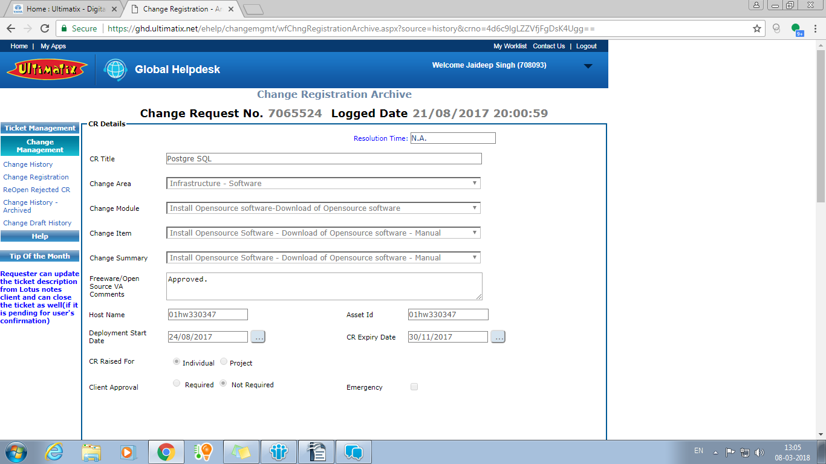

4)Change the hba_config file access setting (Internal IT ticket )

|  |
| --- |
| Need to make changes in below file: C:\Program Files\PostgreSQL\9.6\data\pg_hba.conf to add below details in file so that all the tam can use the database for Thinkpro posgreSQL database , For Asset ID-01HW382662 IPv4 local connections: host all all 0.0.0.0/0 trust |

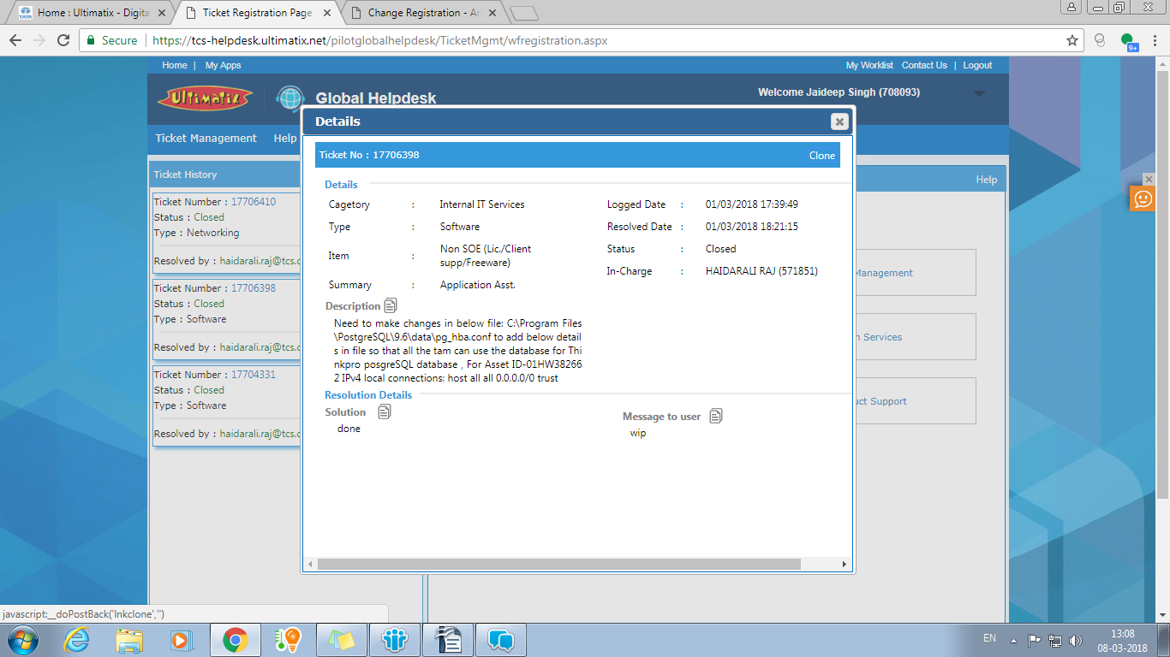

1. Fix IP of server machine (CR Required)

